BIX is nothing but Business intelligence Exchange

We can add the Pega BIX ruleset to our application

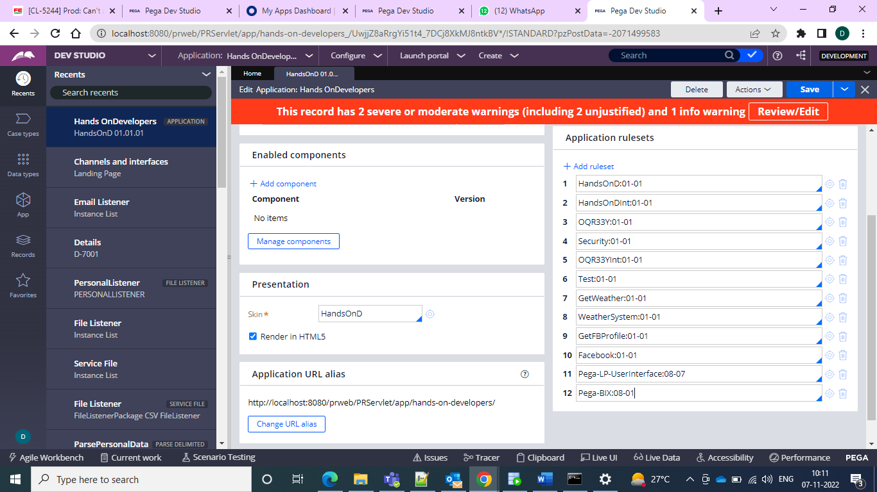

We can now find from the records explorer and in the extract we can see the extract in the sysadmin

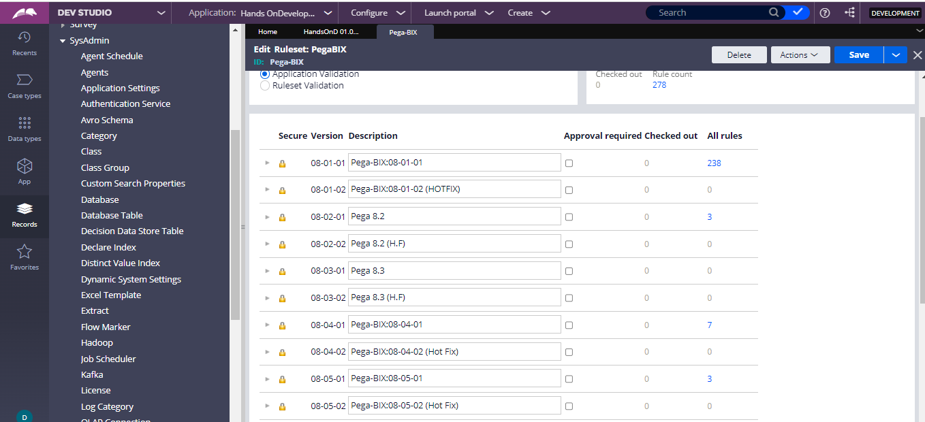

And after that we can see the extract rule is created by right click extract and then we can see the below screen

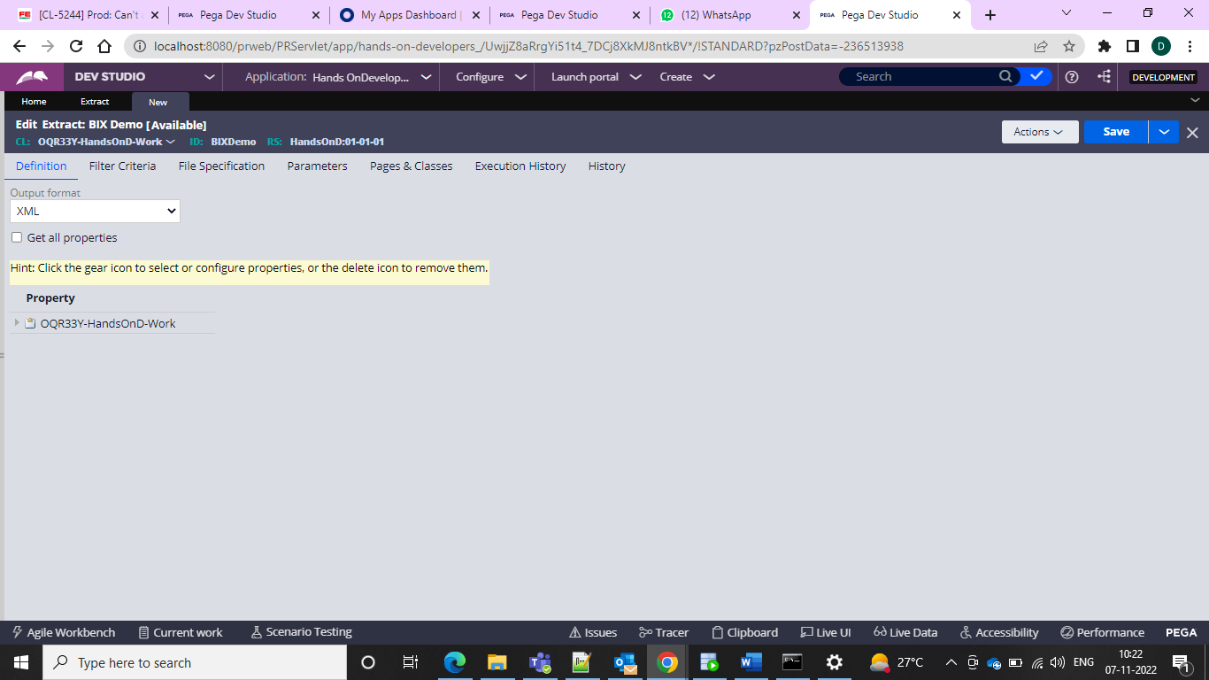

And since we do not have any schema database for now we can go for the CSV file format and give the connectivity and it should be success

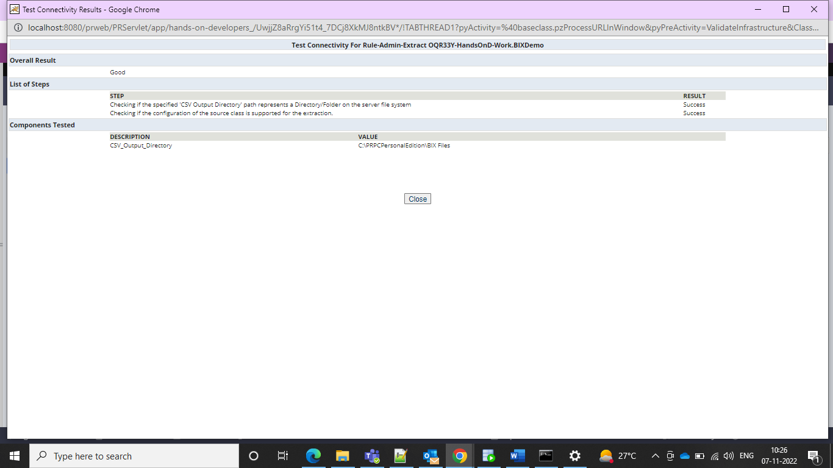

And after that we can do an action run and we can get the below popup to perform the extract and then we can go for the extraction

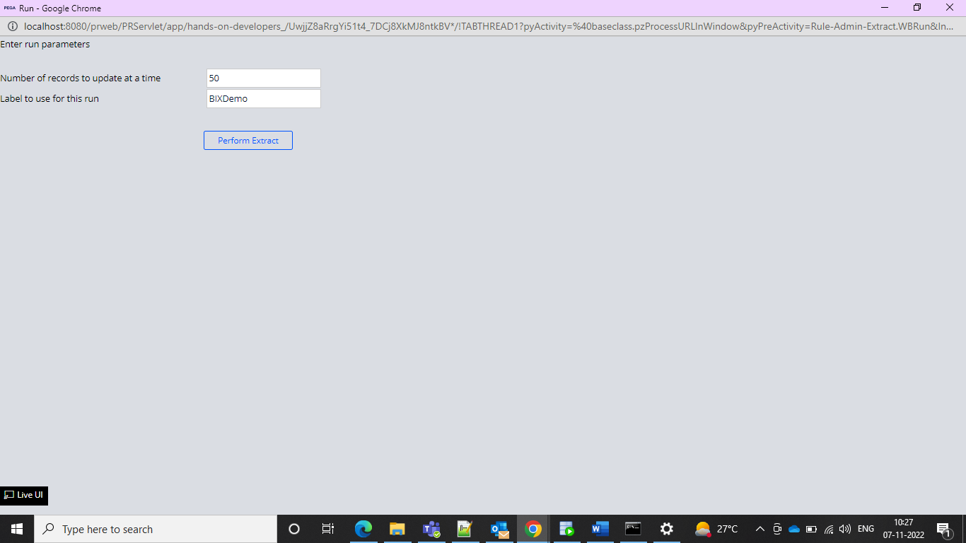

And in our file directory excel file would be created and then we can see the excel file got created and checked and updated there

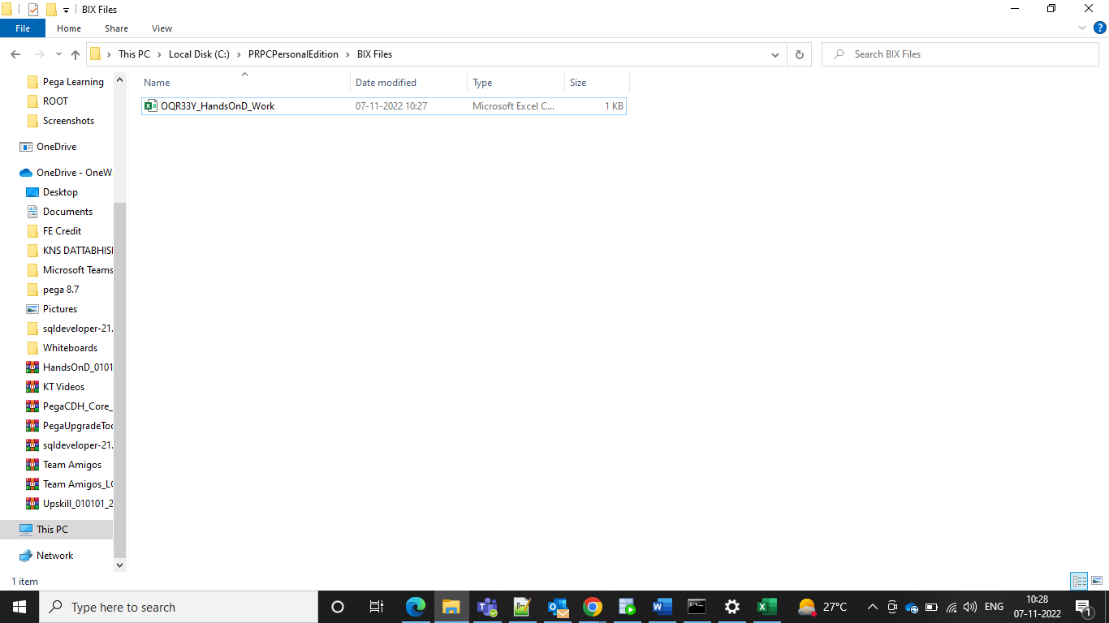

And after the excel is opened we can see the records if zero processed we can get the 0 records but columns

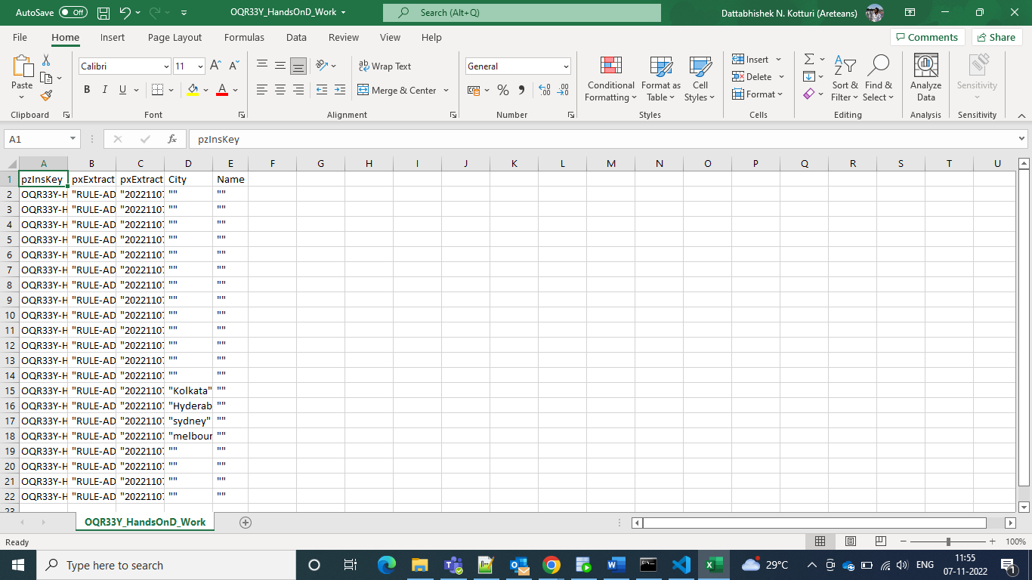

We have one OOTB activity under rule-admin-extract and we can use that for extraction.

If using Database Schema we need to specify the database in file specification

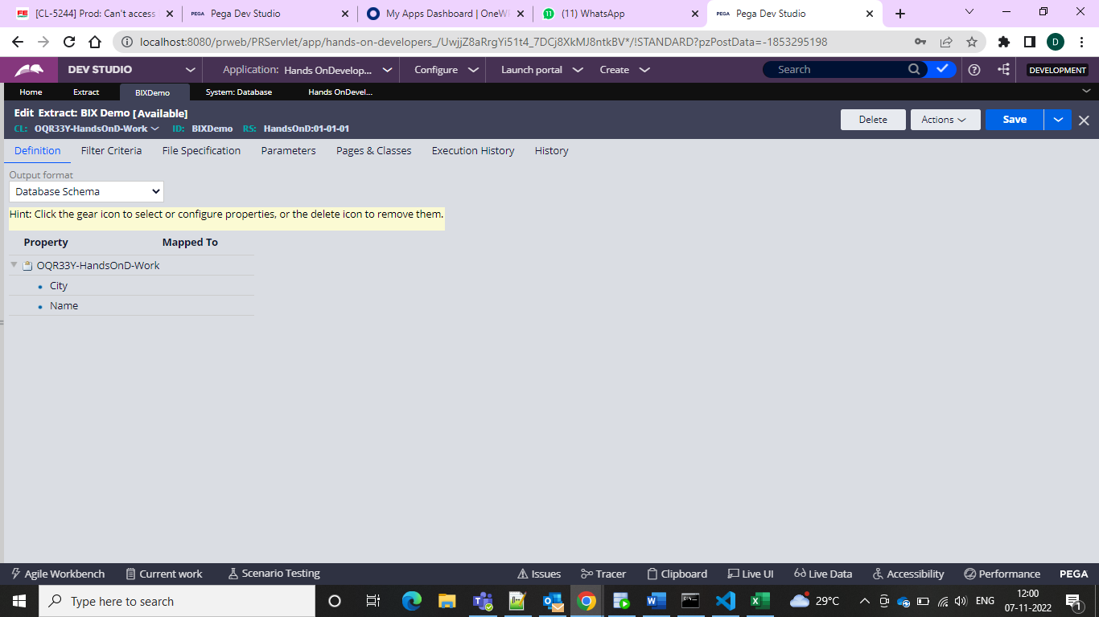

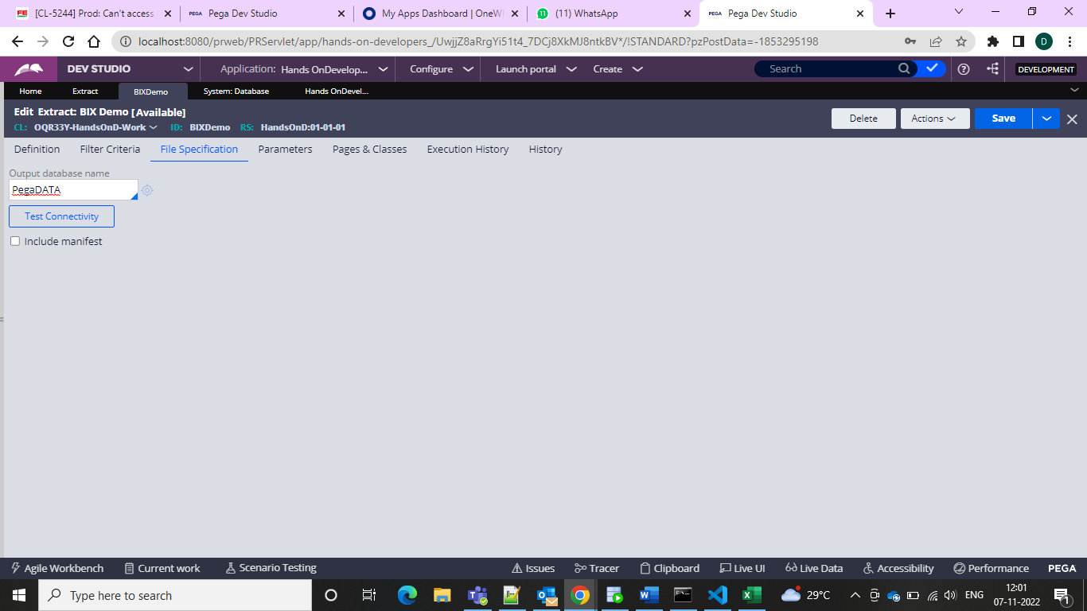

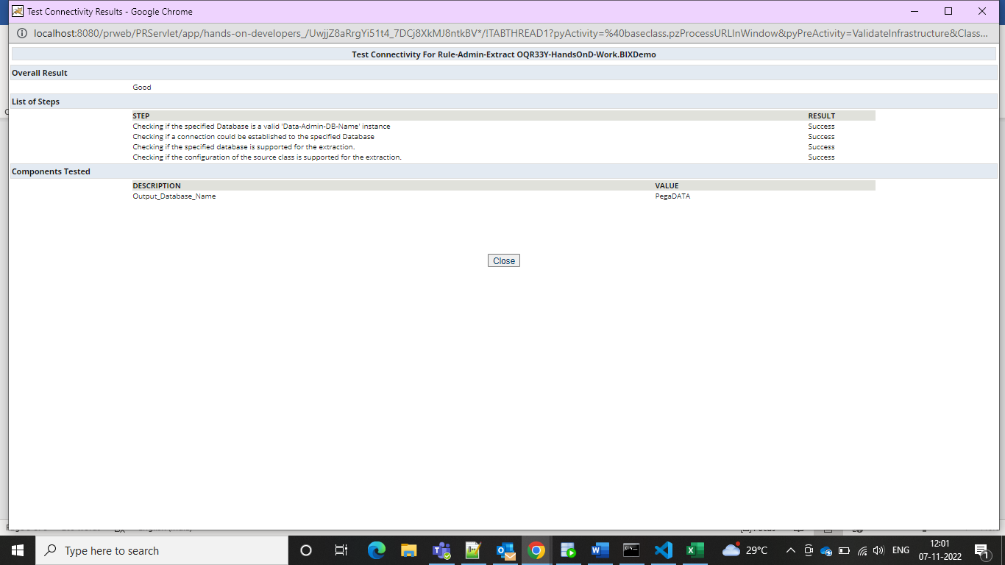

We need to make sure that we have table with properties so we can use generate Schema DDL to check it

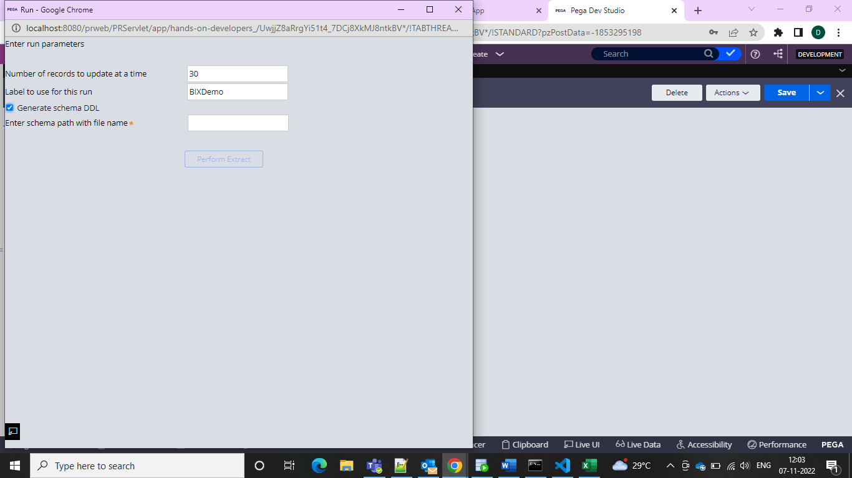

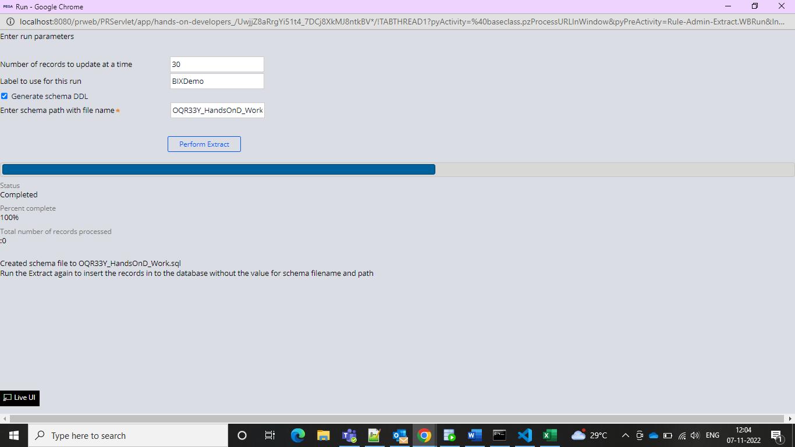

And the schema file with sql file created can check in the folder

After the creation of the schema files we can see the properties in the folder

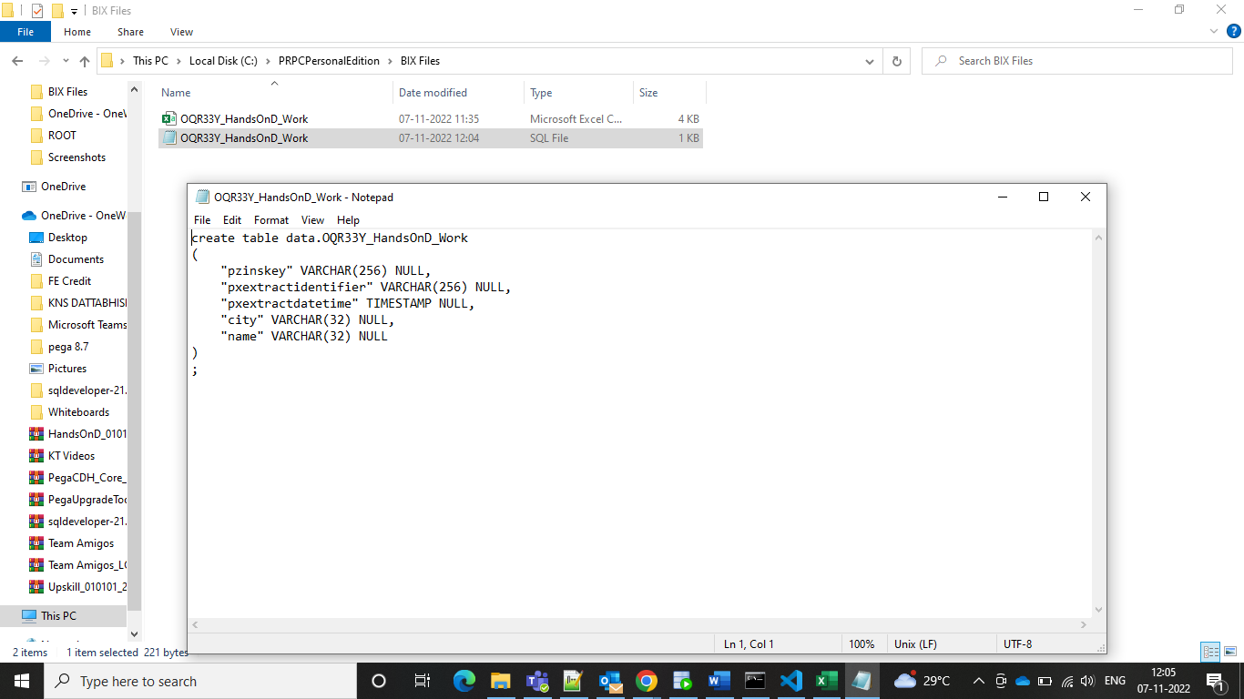

So these columns are there so we can insert the records now

So we can get the records when extracted from postgres SQL and get the records and get the usage

Now extract your BIX and see the records in the SQL DB or not.

Before this we need to see our server in postgres SQL

Create as the hostname as localhost and username as postgres and password as postgres

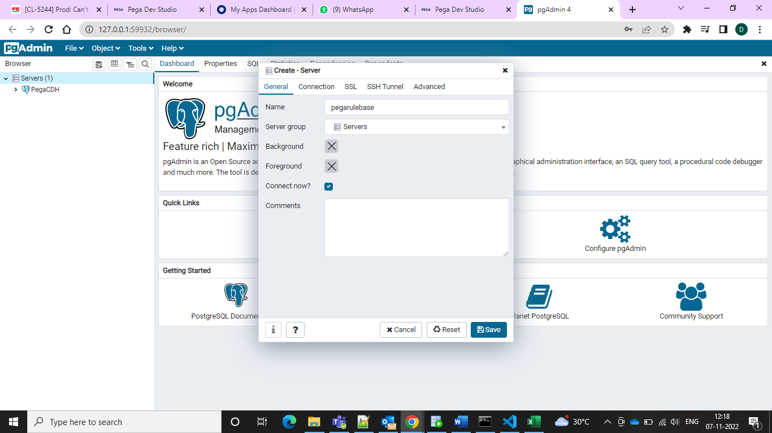

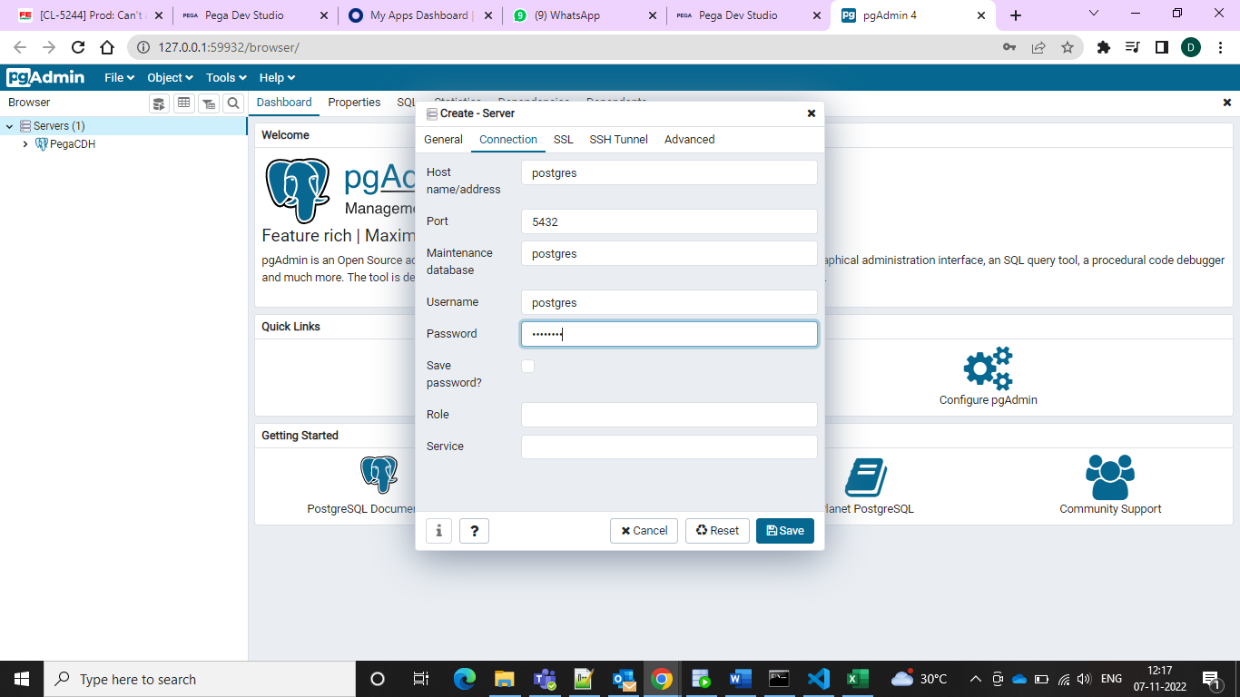

And after this we will see schema and tables and after seen we can run the BIXextract and see that it works or not.

It populated for me can refer the screenshot below.

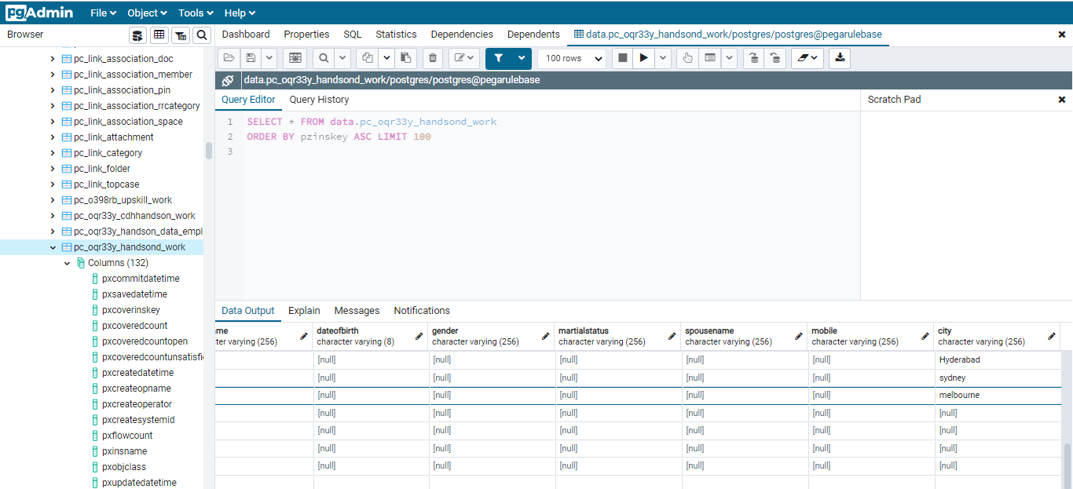

The activity is shown as the pxExtractDataWithArgs

And we need to specify the things here and create job scheduler

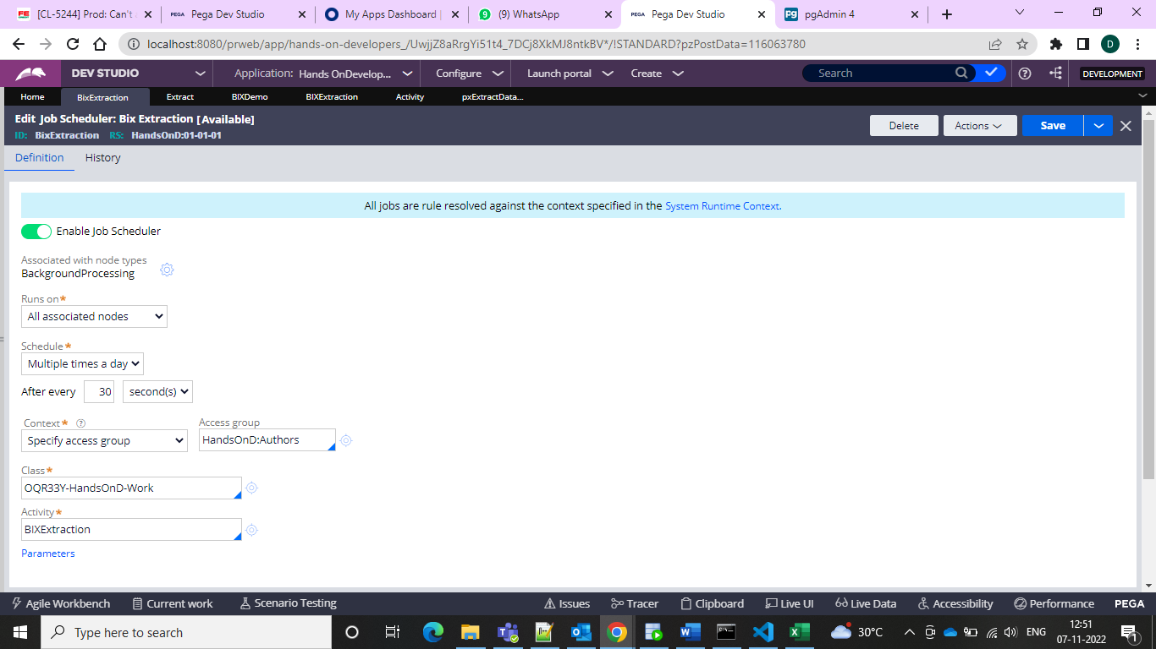

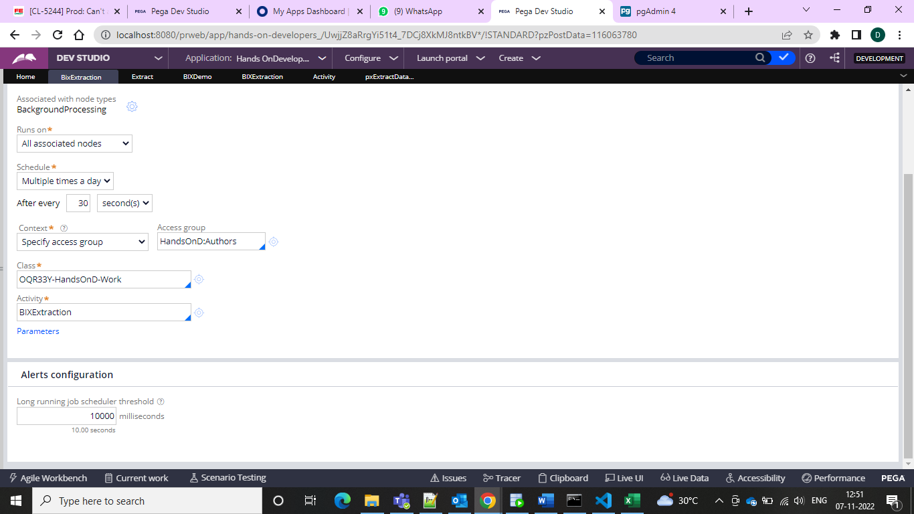

And configure the activity

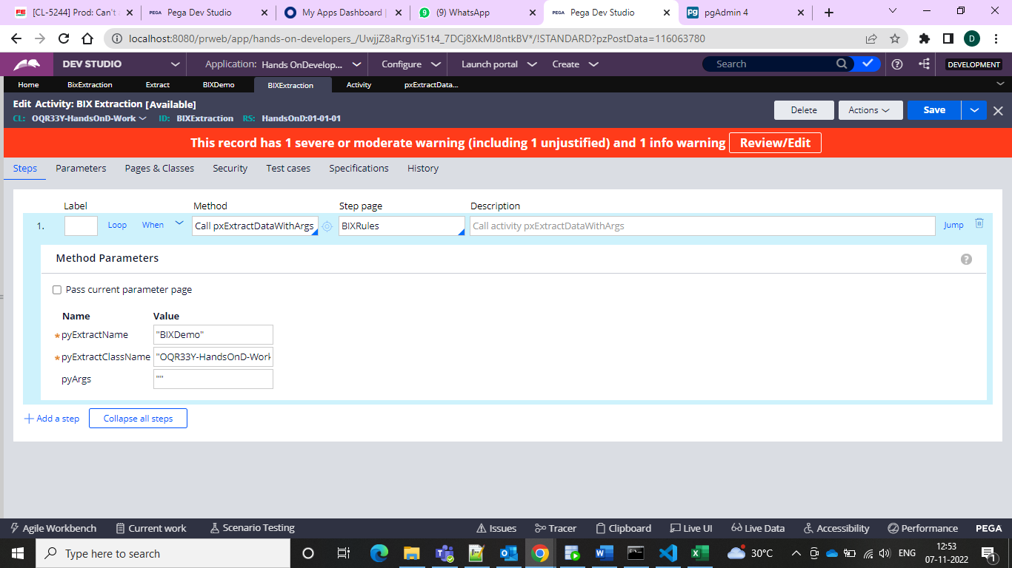

And we can do in this way also BIX extraction

And now we can use the Another Database schema to create the cases and the table

So in the BIX rule we can select the output format as the database schema